Using Infinite Loops

# **Description**

This tutorial is a guide for making infinite loops in Vex IQ RobotC programs

# **Instructions**

1. Look on the desktop for the Robot C icon. Select the “RobotC for Vex Robotics”  
   Do not open the “Graphical ROBOTC” program  
   1. 
2. Open a new file and enter the following  
   1. 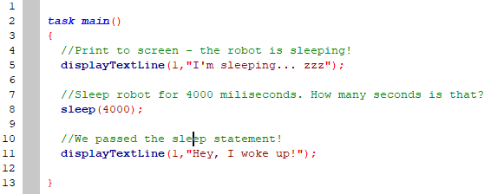
3. Compile, Download to Robot, and Start
   1.  🡪  🡪 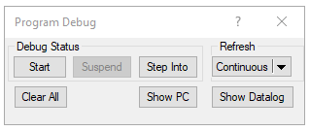
4. The robot should print the “I’m sleeping” message, sleep (wait) for 4000 milliseconds, and wake
5. Make it infinite! Add an infinite while loop to make this program run forever!  
   1. 